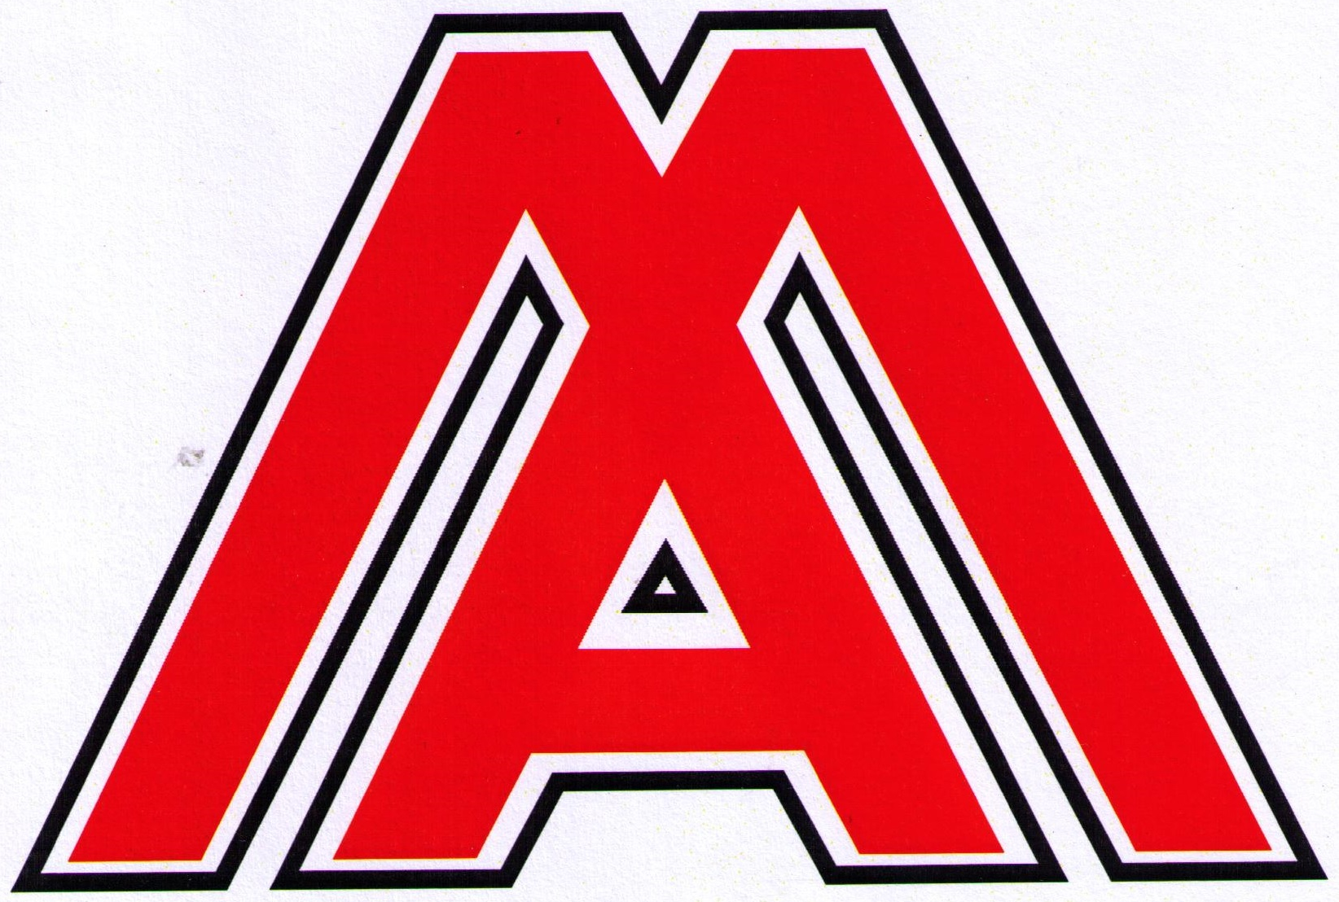
MO B I L E A P P L I C A T I O N S LTD DTDT D
14 Chemical Lane, Longbridge Hayes Industrial Estate
Longport, Stoke-on-Trent, ST6 4PB
Telephone: 0044(0)1782 790824 Fax: 0044(0)1782 790825

ww

website – www.mobileapplicationsltd.com email – sales@mobileapplicationsltd.com

BANDSAW DISCOUNTS FROM 1ST JANUARY 2024

MA630 PORTABLE BANDSAW

1 OFF £1875.00 - (ADD £52.00 IF LIGHT REQUIRED)
2 OFF £1782.00 each - (ADD £52.00 PER M/C IF LIGHT IS REQUIRED)
3 OFF £1688.00 each - (ADD £52.00 PER M/C IF LIGHT IS REQUIRED)
4 OFF £1594.00 each - (ADD £52.00 PER M/C IF LIGHT IS REQUIRED)
5 OFF £1500.00 each - (ADD £52.00 PER M/C IF LIGHT IS REQUIRED)

WHEN PURCHASING 5 MA630 IN A SINGLE TRANSACTION – YOU WILL SAVE £1,875.00
THE LIST PRICE FOR 1 MA630

ALL MACHINES SUPPLIED WITH ALUMIMUM WHEELS

CARRIAGE CHARGE £70.00 FOR ONE MACHINE WHEN DELIVERED WITHIN THE UK

WEB SITE:- www.mobileapplicationsltd.com

E MAIL:- sales@mobileapplicationsltd.com

